7. Careers


BUILD YOUR CAREER WITH US.
Join a growing team delivering infrastructure, connectivity, energy and technology projects across Nepal.
We welcome applications from engineering, technical, field, project coordination and support professionals, as well as students seeking internship opportunities.
Send Your CV ↗ [this is for general use, anyone can apply, ask for Desired position of the applicant in the form]

Ask cv of open vacancies in the following format.
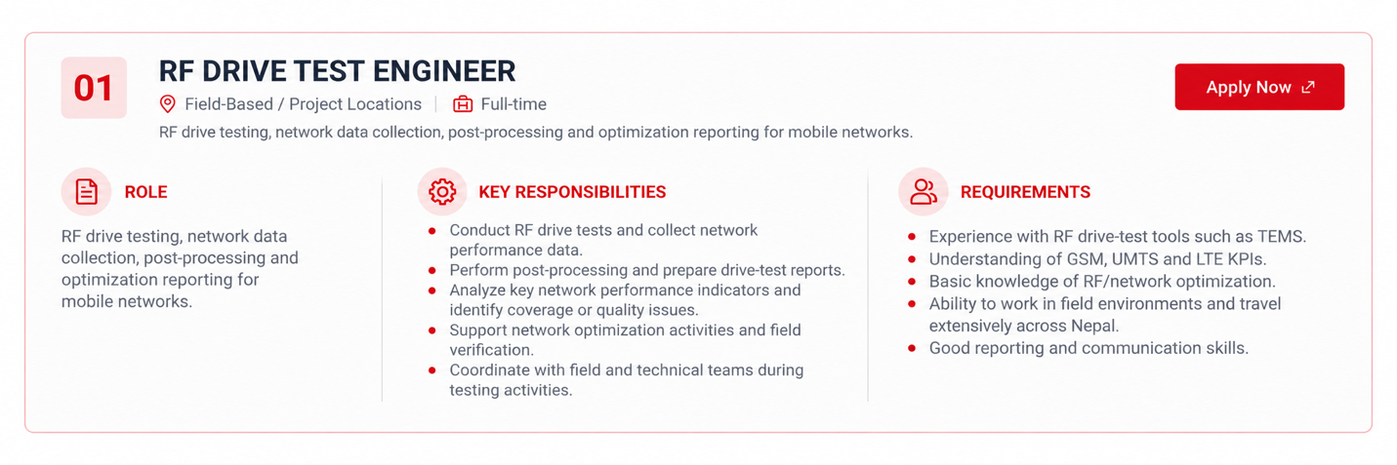

Make the following vacancies.

01 — RF DRIVE TEST ENGINEER
Location: Field-Based / Project Locations
Employment: Full-time

ROLE
RF drive testing, network data collection, post-processing and optimization reporting for mobile networks.

KEY RESPONSIBILITIES
* Conduct RF drive tests and collect network performance data.
* Perform post-processing and prepare drive-test reports.
* Analyze key network performance indicators and identify coverage or quality issues.
* Support network optimization activities and field verification.
* Coordinate with field and technical teams during testing activities.

REQUIREMENTS
* Experience with RF drive-test tools such as TEMS.
* Understanding of GSM, UMTS and LTE KPIs.
* Basic knowledge of RF/network optimization.
* Ability to work in field environments and travel extensively across Nepal.
* Good reporting and communication skills.

Apply Now ↗

02 — RF Data Analyst
Location: Office-Based
Employment: Full-time
ROLE
Responsible for RF data post-processing and technical reporting based on drive-test logs, SSV, cluster testing and customer complaint data.
KEY RESPONSIBILITIES
Post-process RF drive-test logs using Actix.
Prepare SSV and cluster analysis reports.
Analyze GSM, UMTS and LTE KPIs.
Prepare customer complaint analysis reports.
Identify coverage and quality issues from RF data.
Prepare clear technical reports, charts and KPI summaries.
REQUIREMENTS
Practical experience with Actix and RF data analysis.
Good understanding of GSM / UMTS / LTE KPIs.
Experience in SSV and cluster report preparation.
Proficiency in Microsoft Excel, Google Earth and MS Word.
Knowledge of mobile network RF performance and optimization.

Apply Now ↗

03 — RF TECHNICIAN / RIGGER
Location: Field-Based
Employment: Full-time
RF field technician responsible for tower climbing, antenna installation and adjustment, azimuth optimization and MT optimization.

Requirements
* RF field and tower-climbing experience
* Knowledge of antennas, azimuth and tilt
* Experience in azimuth and MT optimization
* Willingness to travel to project sites
* Safety awareness for work at height

Apply Now ↗

8.Contact
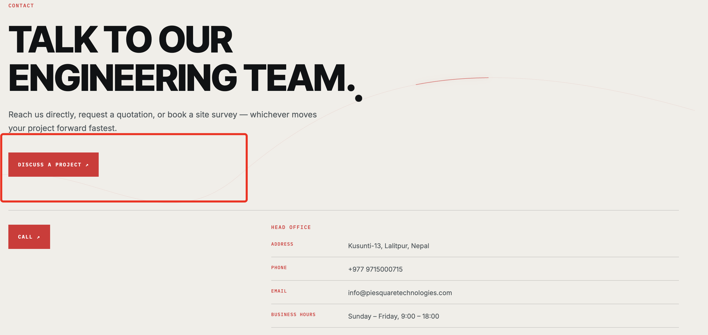
Remove Discuss a project and put below attached content- call, whatsapp, email like attachment.
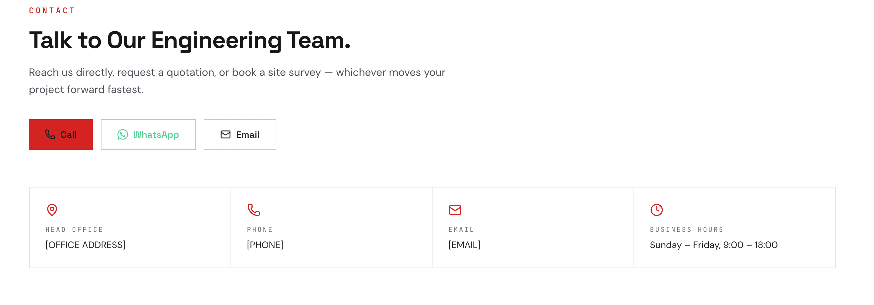
Better put same as we shared you sample.
-Also put google map location if possible as in sample.
Location link -https://maps.app.goo.gl/c1qiB9XLx6HiBsWu9?g_st=ic
